|  |  |  |  |  |  |  |
| --- | --- | --- | --- | --- | --- | --- |
| Severity | Code | Description | Project | File | Line | Suppression State |
| Error |  | Package Microsoft.AspNetCore.Mvc.RazorPages 2.1.0 is not compatible with netcoreapp2.1 (.NETCoreApp,Version=v2.1). Package Microsoft.AspNetCore.Mvc.RazorPages 2.1.0 supports: netstandard2.0 (.NETStandard,Version=v2.0) |  |  | 0 |  |

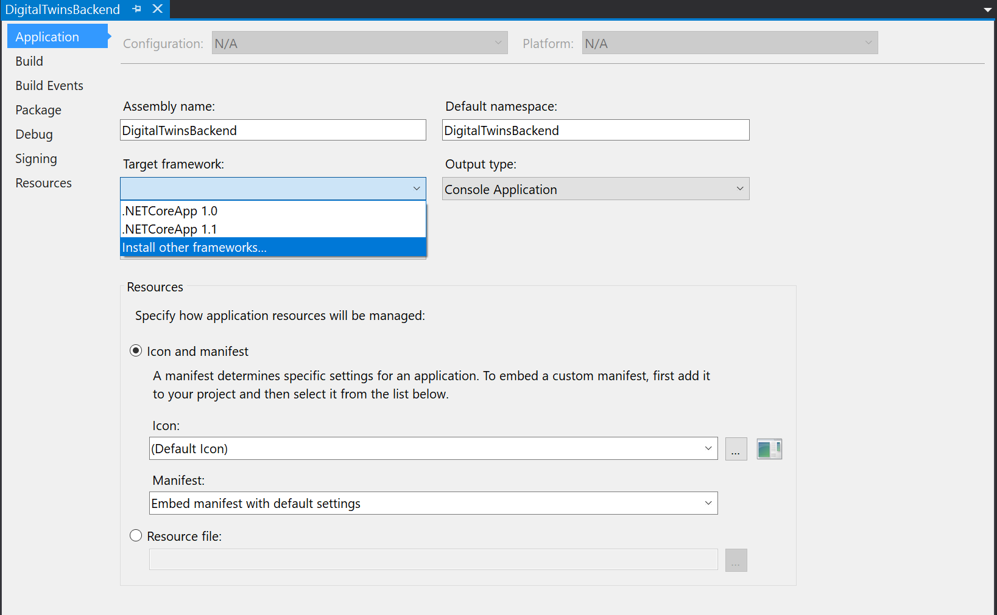

<https://dotnet.microsoft.com/download/visual-studio-sdks?utm_source=getdotnetsdk&utm_medium=referral>

[x64 SDK](https://dotnet.microsoft.com/download/thank-you/dotnet-sdk-2.1.503-windows-x64-installer) | [x86 SDK](https://dotnet.microsoft.com/download/thank-you/dotnet-sdk-2.1.503-windows-x86-installer)   
(v2.1.503)